**TRAINING REPORT ON UTC 3 & 4 ORGANISED BY FOUNDATION FOR CHANGING LIVES AGAINST SUBSTANCE ABUSE IN NIGERIA, DATED 26Th February, 2024.**

**Report prepared by Dr. Chia Francis (ICAP II).**

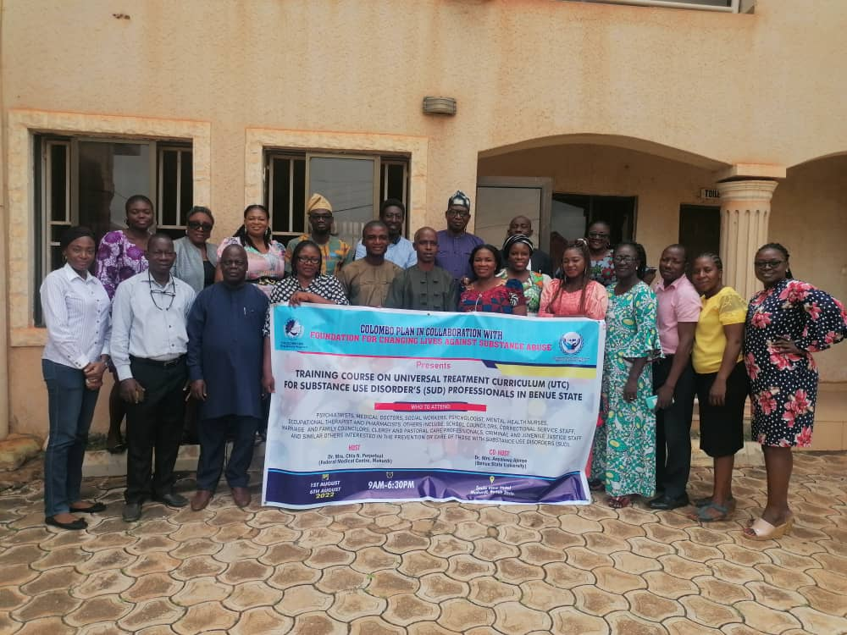**Participants for UTC 3 & 4 posed for a group photograph in Makurdi, Benue State Capital City.**

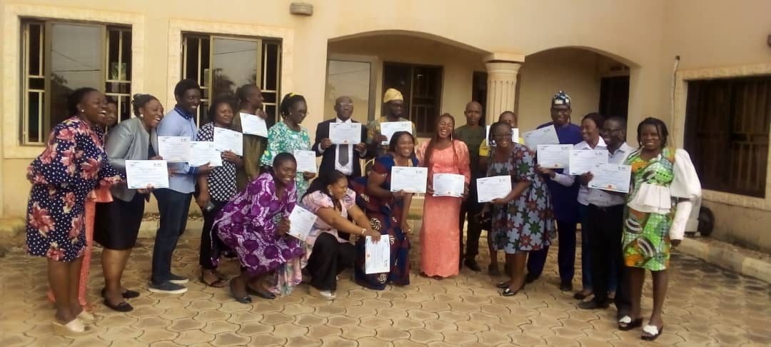

**Participants above & below celebrating the receipt of their beautiful certificates**

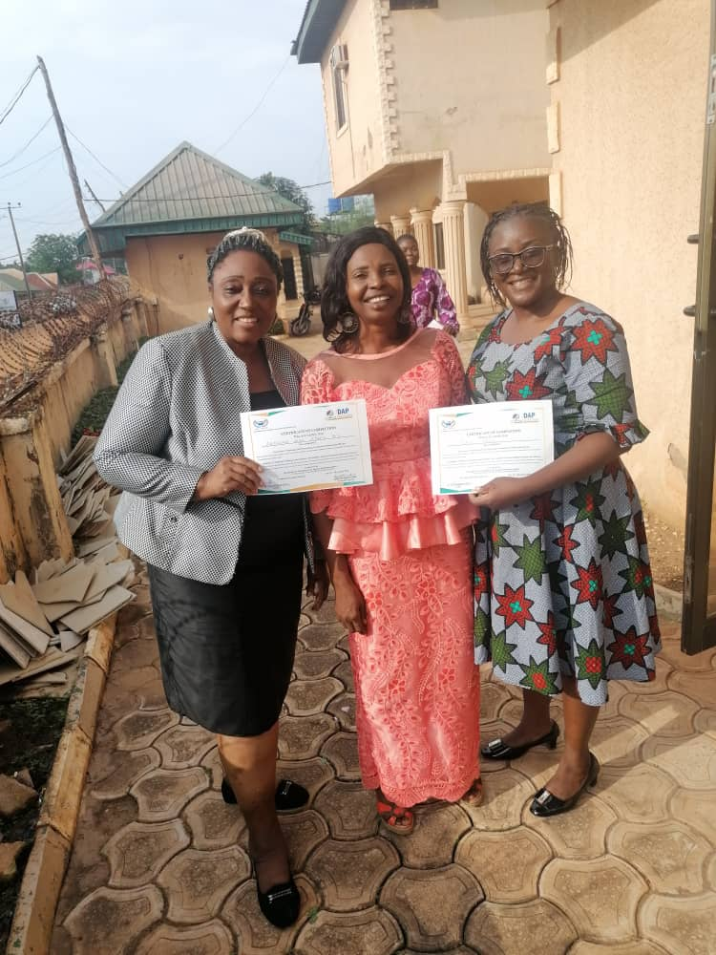

**Summary**

The training on Universal Treatment Curriculum 3 & 4 organized by Foundation for Changing Lives Against Substance Abuse (FOCLASA) took place between 26th to 1st March, 2024 at the Heiphzah Plaza, Makurdi, Benue State, Nigeria. Ten (10) people registered and successfully completed the course. The training was facilitated by Dr. Chia Francis (ICAP III) who is a UTC national trainer in Nigeria. The trainer strictly used the UTC 3 & 4 materials developed by the Colombo-Plan to deliver the training program. Result scores from the pre-test and post-test on each of the curriculum showed a great improvement in knowledge among the participants in both UTC 3 & 4.

**Introduction**

Foundation for Changing Lives Against Substance Abuse in cognizance of the prevailing challenges of drug abuse in Nigeria as documented by the UNODC Report of the first-ever national survey in Nigeria on drug use released January, 2019 has put up this program to address especially the challenge of low addiction workforce in the country. This program was seen as a welcome development by practitioners in drug addiction field in Benue state as they raised their concern of practicing but with limited knowledge. Furthermore, the knowledge at hand is narrowly evidence-based. At the end of the training program, the training provider entered into a general discussion session with the participants and one take-home common to all the participants was that the program has updated and expanded their knowledge in the field of addiction science. In view of this, all the participants requested that the education provider should not delay in announcing the next training course i.e UTC 6, 7 & 8. In quick response to this request, both the education provider and the participants further discussed and reached an agreement that the next training course should commence on the 1st - 8th July, 2024 in Makurdi, Benue State Capital.

**LIST OF SUCCESSFUL PARTICIPANTS FOR UTC 1 & 2 in Makurdi.**

|  |  |  |  |
| --- | --- | --- | --- |
| **S/N** | **Title & Surname** | **Middle name** | **Another name** |
| 1 | Prof. Elvis | Obulu | Ihaji |
| 2 | Dr. Chia | Ngosoo | Perpetua |
| 3 | Dr. Anyalewa | Alan | Ajonye |
| 4 | Dr. Time | Alphonsus | Terna |
| 5 | Dr. Akpenkaan | Mwuese | Pauline |
| 6 | Dr. Victor | Odeh | Ojobo |
| 7 | Dr. Ighagbon | Festus | Omo |
| 8 | Atile | Phoebe | Ibee |
| 9 | Moses | Denen | Chiahemba |
| 10 | Oibiokpa | Michael | Oibiokpa |
| 11 | David | Helen |  |
| 12 | Akura | Joyce | Erdoo |
| 13 | Mrumun | Gertrude | Afaor |
| 14 | Stella | Wanyima | Atim |
| 15 | Sanyu | Nicole | Eimiehon |
| 16 | Kanu | Uzoma | Faustina |
| 17 | Abu | Grace | Orako |
| 18 | Aboje | Matthew | Ojebe |
| 19 | Francis | Kyernum | Udzua |
| 20 | Mashika | Mimi | Patience |
| 21 | Uzzi | Osahon | Henry |

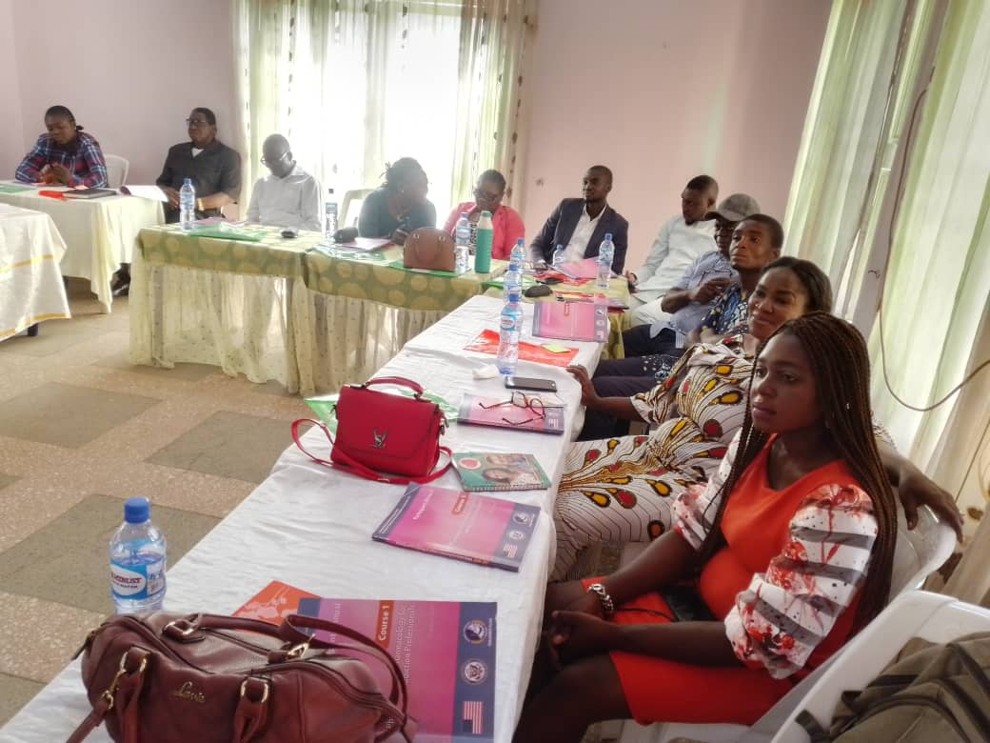

**Picture of participants sternly looking at the screen during a training session.**

**Materials & Equipments:**

Materials used during the program as displayed on the table below were re-produced copies of complete participant’ manual on Curriculum 3 & 4 originally developed by the Colombo-Plan. Other materials and equipment’s used include: Newsprint pads, markers, cardboard sheets, computer and projector.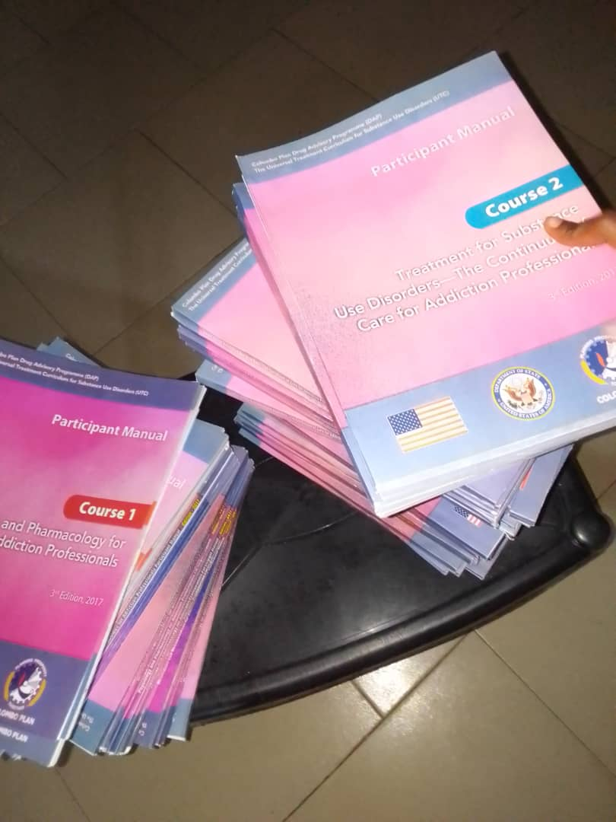

**Some training materials used for the training e.g (UTC 3 & 4 booklets)**

**Methodology**

In addition to lecturing method, other methods were used in conducting the training as seen in the pictures below, e.g Group work, group presentations, participant sharing of personal experience, whole class collaborative exercises, energizers etc.

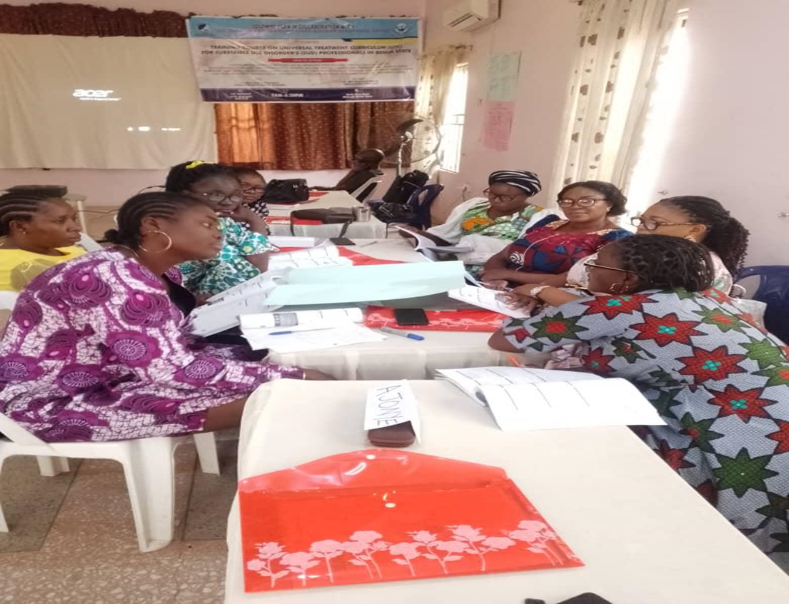

**Group one above during group work brain-storming session on day 1**

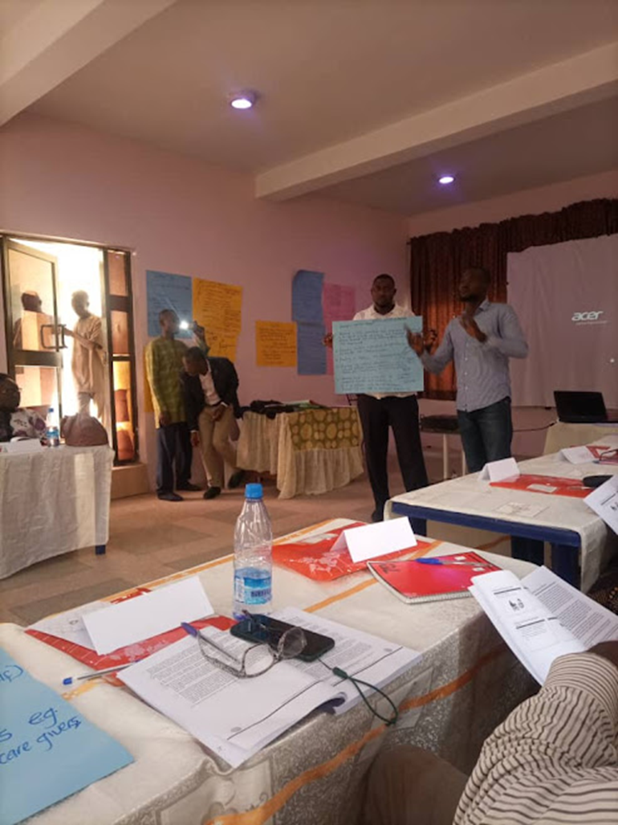

**Group one above presenting their work after group discussion on day 2.**

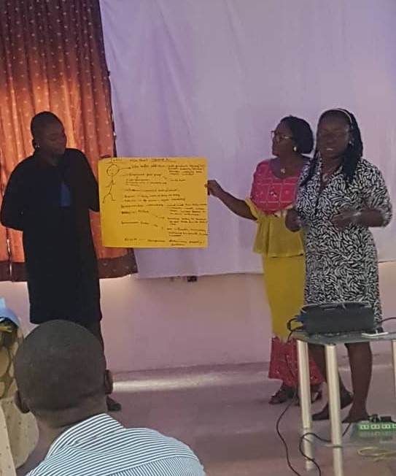

**Group two above presenting their work after group discussion**

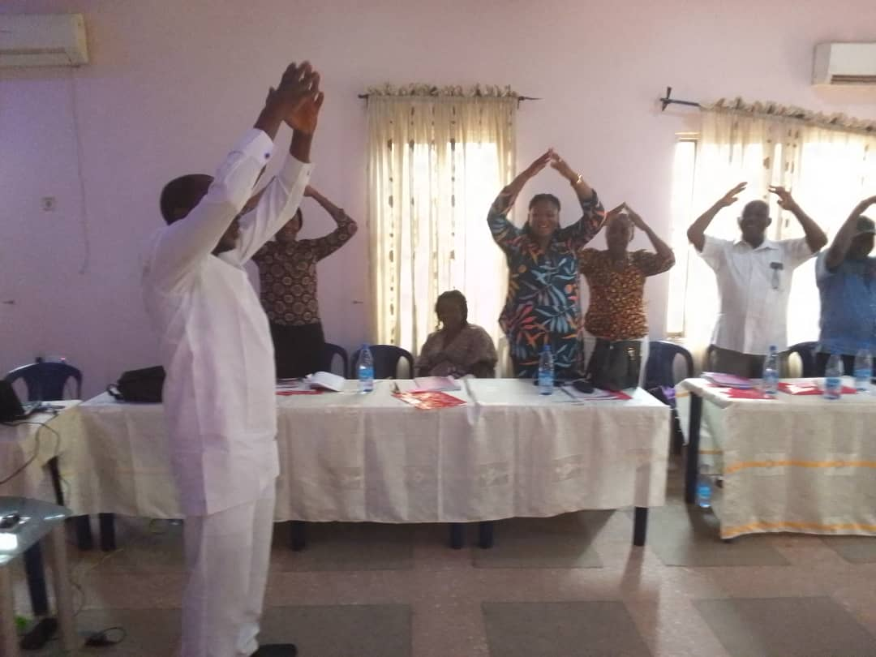

**Above is participants performing an energizer after lunch-break**

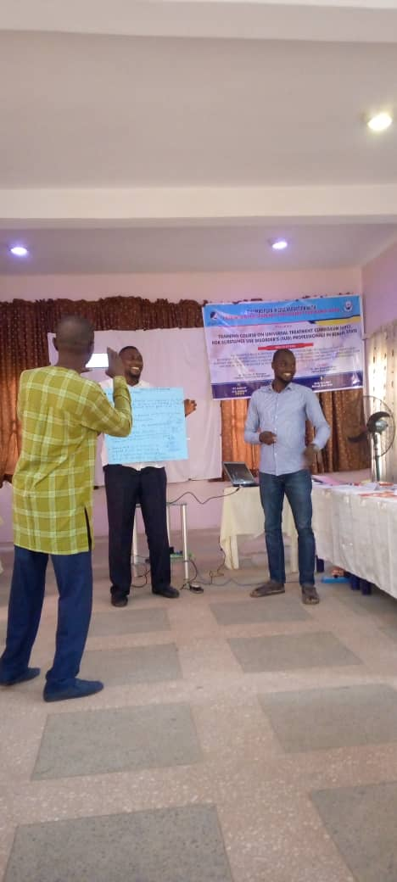

**Group three presenting their work after group discussion**

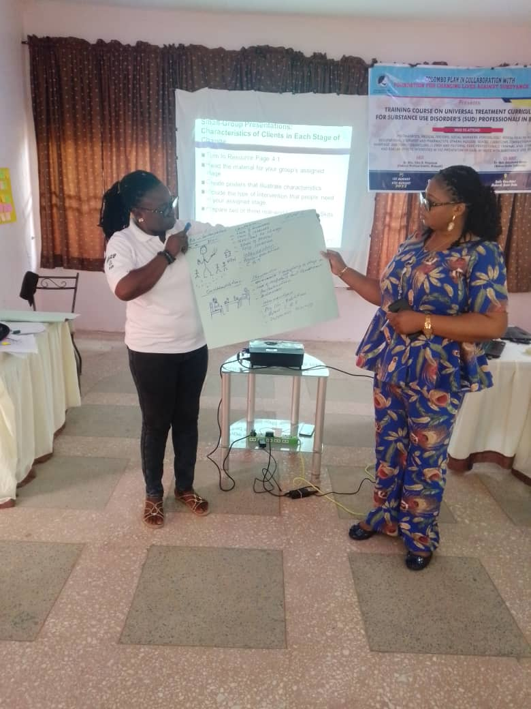

**Group four presenting their work after group discussion**

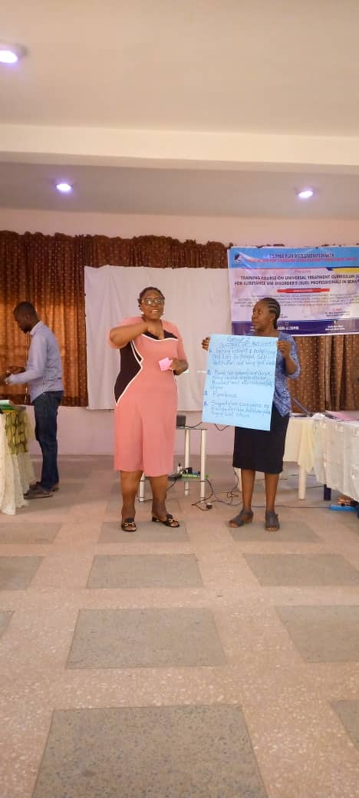

**Group two presenting their work after group discussion on day five**

**Participants Feedback**

**HELEN DAVID**

I really enjoyed every aspect of this training and it is going to have a resounding impact on my profession. My participation in this training has given me new ways of thinking and doing my work in order to achieve excellent result. I am therefore with full confidence that as I move through the training to the end, my knowledge base and skills will move from one level to another and my practice will never remain the same. On this note, I really thank the education provider that has brought this program to us and I believe we will never be a disappointment to this wonderful opportunity that has come our way. **Cheers!!**

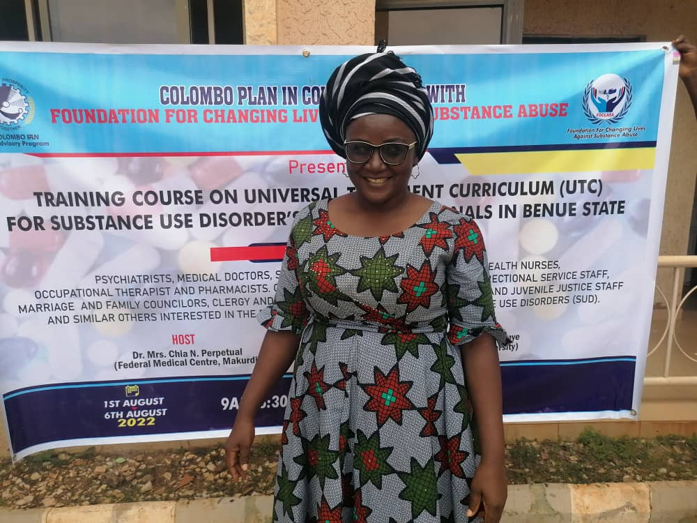

HELEN DAVID

**AKURA JOYCE ERDOO**

This training on universal treatment curriculum for substance use disorder is a timely training that has an answer to many of our challenges especially the challenge of lack of trained addiction professionals in the country. I have been working in the field of substance abuse for some years but the experience gained at this workshop shows that so many important things has been missing in my practice. This experience of mine I believe is common to other participants in this course as well. I wish to state here that I really enjoyed the groupwork as group presentations make the training more practical and meaningful to me. Furthermore, I am glad that very soon I will become a certified addiction professional and I believe my fellow participants shares this same joyful hope.

It has really been worthful time spent together and I enjoyed it.

**Thank you.**

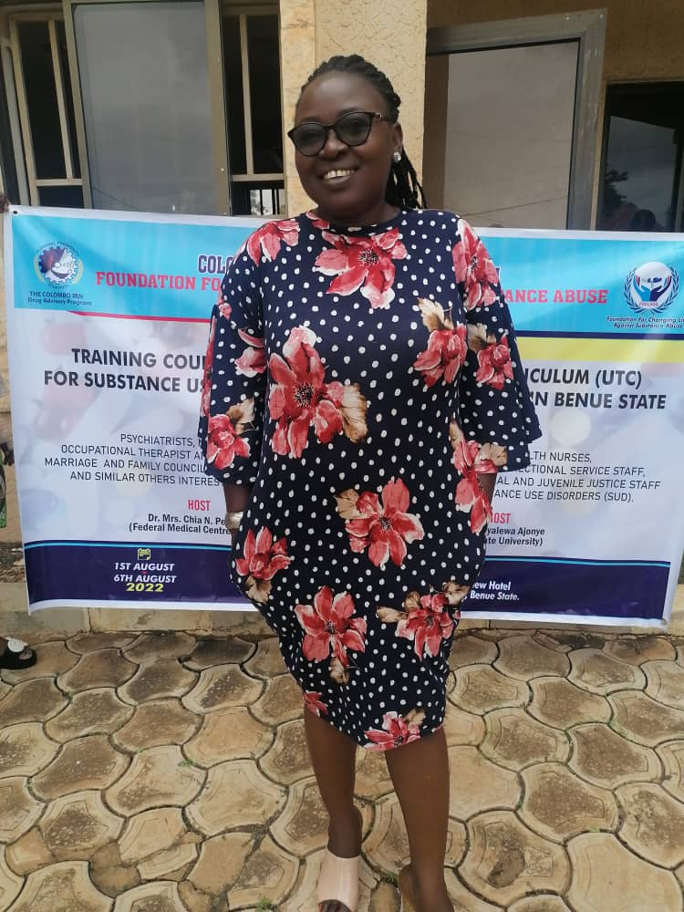

**AKURA JOYCE ERDOO**

**Conclusion**

The goal for organizing this training was realized as there was increase in participants knowledge on the taught curriculum. At the end of the week-long training, participants gladly discussed with the education provider and scheduled the next training on UTC 6, 7 & 8 by first were of July, 2024.